Light Attraction-Based Bird Conservation is Fatally Flawed.

A Logical and Linguistic Analysis

Prepared by James M. Cubie, J.D. Consultant Acopian Center for Ornithology

Thesis The attraction-based Lights Out program will produce no net benefit because if some windows are shuttered, the birds will be attracted to others that remain lit and hit them. This will be referred to as “displacement” in this text.

This essay will address this issue from logical and linguistic perspectives.

This issue has been raised by Dr. Daniel Klem, the nation’s leading expert on bird window collision, Dr. Christine Shepherd, the ornithologist at the American Bird Conservancy, and by the reviewer of the Van Doren paper.(PNAS, 2021) This paper is the primary cited evidence for light related collision prevention programs.

In legal forums, the logic of proffered argument is carefully considered before a judge in which contrary views are expected to be presented Avian conservation policy is not developed in this way. There is no forum in which contrary arguments to a proposed conservation policy can be presented. A policy recommendation is different from a biological finding which should be examined in the peer review process. Typically peer reviewed biological papers do not contain “policy” recommendations– though both Van Doren and Lao (Biological Consersvation,2020) papers state policy conclusions.

Second, in evaluating an argument, lawyers are trained to examine carefully the language used in an argument.

I have posed the question, “if some windows are shuttered, won’t birds be attracted by lights and hit other windows which are still lit?” If so, there will be no net birds saved by turning off lights. The two most cited studies are by Van Doren (PNAS, 2021) and Lao (Biological Conservation 2021. Both found that if (some) birds are flying toward a building they will be attracted to a lit window more often than a shuttered window.

Summary

- If Van Doren and Lao are right- that light attracts some birds to hit windows- logically they will hit other windows that remain lit.
  - Migrants encounter innumerable windows during migration, to which they will be attracted, and collide with
- Van Doren claims “this is not so.” He rejects this thesis because: when he compared the “total building lighted window area and predicted collision counts” he found that there is a positive, though subtle, relationship between” them.
  - In statistics “subtle” means virtually no difference.
  - The tenuousness of this analysis is shown by his use of the term “subtle. At other points in the paper, he uses the phrase “strongly predicts” when his analysis yields convincing results.
  - His argument misses the point. It is based on the windows in one building it is simply not relevant to migratory birds where there will be hundreds of thousands or millions of lights to attract birds.
- Objection: “Collison prevention has the same problem. If collision prevention systems are installed on a window, birds will just hit windows without collision prevention.”
  - Birds are not attracted to darkened windows. If the collsion prevention system convinces the bird not to fly toward a darkened window, he may choose any other flight path.
  - If Van Doren and Lao are correct, light directly affects a bird’s choice and it will hit a lit window.
  - Examples of collision prevention systems are at Feather Friendly – FeatherFriendly

Section 1. If Van Doren/Lao science is sound, no gain by lights out strategy.

The first row below shows two windows at the McCormick Convention Center studied by Van Doren. One is shuttered (black) and one is lit (yellow). Because there are more hits at the lighted window (yellow) at the Convention Center Van Doren argues it proves lights attract birds – sparrows especially.

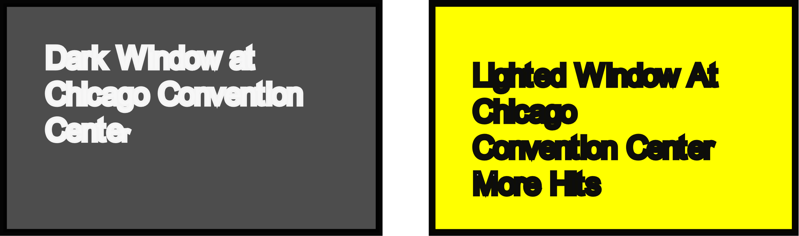

Second, let us move those windows downtown and place them in a building; represented by the blocks below. Volunteers convince the manager of the left window to turn off his lights (black). The manager of the right window does not cooperate and leaves the window lit (yellow). If the two windows above prove that lights attract birds, birds will be attracted to the yellow window in the downtown example below. To contend the opposite is to say that the science established at the Convention Center – row one- is wrong.

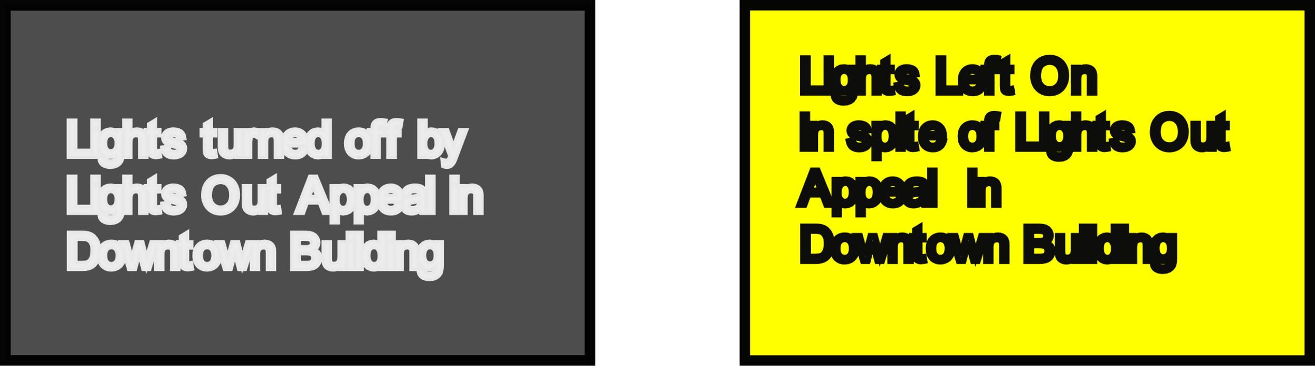

Section 2. Van Doren responds: “The Science Says that You are Wrong.”

In arguing against displacement, Van Doren uses the weak term –“subtle” to describe his results. Where his analysis is conclusive, he uses the phrase “strongly predicts. ”

In response to my statement on a listserv that “birds will just hit other windows,” the author of the Convention Center study states: “The science shows that you are wrong…” It is a very strong statement which delivers the message that “it is not even a close call.” He contends “science’ shows birds will not hit other lit windows.” It will not happen. The “science” in question is quoted below in full from the PNAS aper.

It comes down to a linguistic question: Is there a difference between the terms ”subtle” and “obvious?” or between a “subtle” finding or statistics that “strongly predict?” As an attorney I have been trained to examine texts very carefully. Words matter. I am sure that a peer reviewer would understand the difference as well.

The author makes his argument in the following text. He bears the burden of proof because his contention is counter to the logical application of the biological evidence in both his study and Lao.

Below is the text from Van Doren p. 5.

“Our results are most applicable to structures with large areas
of lighted windows, which raises an additional question (1) If individual.
windows are darkened, is this likely to decrease total
mortality or simply cause birds to collide with other lighted
windows? If the latter were true, we would expect those collisions
at a given window bay would increase when surrounding
lights are extinguished. However, we observed the opposite:
(2)After accounting for individual window-bay lighting, we see,
a positive, though subtle, relationship between total building
lighted window area and predicted collision counts (Fig. 5). (3) This
suggests that each darkened window makes it less likely for birds to collide with nearby windows. Additional experiments focused on the effects of individual window lights would be informative.

He answers the reviewer’s query (1) ”will they just hit other lit windows?” in the second highlighted text above. (2) i.e. that there is a positive, though “subtle” difference between total building area and predicted collision rates." He states that this "relationship answers the question of whether birds will just collide with other lighted windows."

“Subtle” in a statistical context means -- “so delicate or precise as to be difficult to analyze or describe.” Or as another dictionary puts it -- “difficult to perceive: obscure.” Yes, positive, but barely perceptible.

If there were a significant difference the appropriate adjective would be “clear, obvious,” or the like.

He clearly knows the difference. He used the term, ‘strongly related,” in the abstract when the data supported his conclusions. Again, on page 6 he states that the lighted window area “strongly predicts fatal collisions….”

So, based on the analysis in the PNAS paper, 99% or 99.5% of the time displacement will occur -- birds will hit other lit windows.

Misses the Point

The PNAS paper only compared collsion rates in one building. The fundamental problem is that there are millions of lights along each migration corridor.

Mr. Cubie worked in the U.S Senate for 12 years in various positions. He was the Democratic staffer responsible for evaluating the policies and programs of 7 Federal agencies, including EPA and NSF. In that position he succeeded in adding funds for the early basic research on global climate change which developed the scientific basis for the present policy. He then served as Chief Counsel of the Senate Agriculture Committee where he was responsible for all legal matters, including evaluating new legislative proposals. During his tenure there was a major reorganization of the Department of Agriculture in which he played a major part. He specialized in farm conservation matters. He developed the Wetland Reserve Program and secured over a billion dollars to restore 3 million acres of drained farmland. After leaving the Senate he organized a non-profit which developed innovative solutions to conservation barriers. One proposal, to reduce the risk perceived by farmers when they changed nutrient management systems, was approved by the Board of the Federal Crop Insurance program. He was also responsible for the energy and environment policy development for a presidential campaign.

He can be contacted at jimcubie1@gmail.com or 843-991-1059

