The Positive Outlook for Residential Bird-Safe Windows

A Report of the Ornithology Center at Muhlenberg College

Dr. Daniel Klem
Director

Jim Cubie, Author
Consultant to the Ornithology Center at Muhlenberg College
October 2023

Contact
Jimcubie1gmail.com
843-991-1059

Related Documents at https://ornithologycenter.com/birdsafeaffordable/

The Cost Of Bird-safe Glass Is Not A Barrier To Its Use In New Residential Construction Or Replacement Windows
Jim Cubie
Ornithology Center at Muhlenberg College
Jimcubie1@gmail.com 843-991-1059

Executive Summary

Residential windows kill several hundred million birds annually. Thus, it is essential that bird-safe glass be used wherever possible. Progress in this effort has been stymied by the assumption that bird-safe glass is too expensive. This analysis shows that is not the case.

The cost of bird-safe glass will not be a significant barrier to its use in the two largest residential glass markets – new homes and replacement windows. This is the case because -

- In new homes the cost of the windows is less than 1% of the total cost of the home. (Source: National Association of Home Builders. p 9.) Therefore, even if bird-safe glass is significantly more expensive, it will increase the monthly payment by only $2-$6 for a $300,000 home.
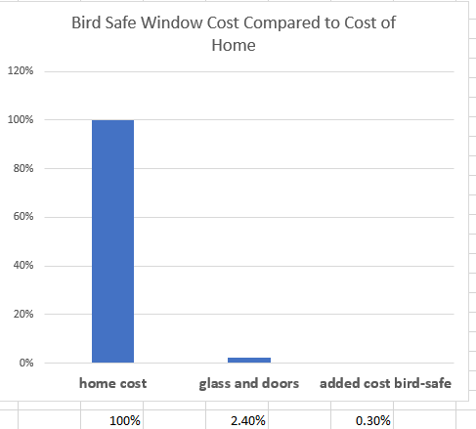Source NAHB , p. 8
- In replacement windows, the glass itself is about 30% of the cost of the installed window. If bird-safe glass costs 25% more than ordinary glass, it only adds 7.5% to the cost of the replacement window – or $30 to the cost of a $400 replacement window. It will increase the monthly payment for 10 windows by between $2 and $10. A single window unit, without bird-safe glass, can cost between $300 and $1,200 for standard sizes – a price range so broad it can accommodate the cost of bird-safe glass. Replacement windows are the second largest market for residential windows.
Spreadsheet, p. 9

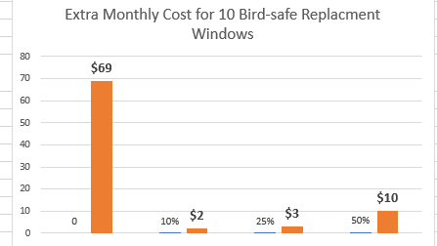

- The price of bird-safe glass will fall dramatically. This graphs show the very large reductions in the price of solar (glass) panels. Solar glass panels were 300% higher than current costs. Bird-safe glass is only 10%-50% extra.

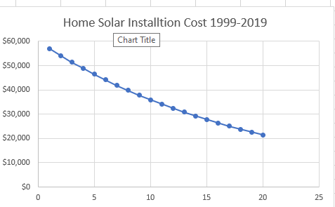

- Portland Audubon Pilot project shows that bird-safe glass in residential windows can be acquired at no extra cost.

Purpose: This memorandum evaluates the effect on consumer acceptance of the possible increased cost of bird-safe glass in residences. It includes both replacement windows and new construction. The availability of bird-safe glass windows is addressed by citing a successful bird-safe project where commercial bird-safe glass was installed in existing residential frames. It does not apply to commercial buildings. A similar study of the commercial sector also found that the cost of bird-safe glass is very.very low. https://ornithologycenter.com/commercial-building-resources/ The conclusions in this summary are the result of an in-depth analysis which are shown in the spreadsheet in the background document. Other important information is there also. It cannot predict prices in every situation.

Two Approaches to Understanding Why Bird-safe glass is so affordable.

- An overall cost percentage. This approach is based on the National Home Builders estimates of the cost of windows in the construction of a new home. In new homes the cost of the windows is less than 1% of the total cost of the home. (Source: National Association of Home Builders. p 9.) Therefore, even if bird-safe glass is significantly more expensive, it will increase the monthly payment by only $2-$6 for a $300,000 home. This is shown in the table below.

4.00% | Windows and doors are 4% of the cost of a new home
2.40% | Materials are 60% of home cost- NAHB - so cost 2.4%
2.04% | less garage door 85%
0.67% | glass 33% of cost of window DOE data
0.84% | only the glass is more expensive, not the whole window - add 25% for bird-safe glass extra cost

- A Scenario Approach. Since we do not know what the extra cost of bird-safe glass is or will be, the best approach is to use several scenarios. The three scenarios assume used in this analysis assume that bird-safe glass is 10%, 25% and 50% more expensive that ordinary glass. This range was confirmed by an industry expert. The costs from the three scenarios provide the information needed to assess the future cost implications of bird-safe glass.
- An Example: Successful Pilot Project by Portland Audubon As part of a renovation of a cabin it owned, Portland Audubon bought bird-safe glass from GlasPro and had a third party install them in JeldWen residential frames. They ended up being no more expensive than the dual pane Marvin windows that had originally been specified for the project.

Three Key Concepts

- Only the Glass is 25% More The idea that bird-safe glass costs may cost 25% or 50% more than standard glass does not mean that a window with safe glass is 25% more costly. The glass itself is only about 30% of the cost of the window installed. Thus, if bird-safe glass costs 20% more, the installed window is only 7.5% more costly. The manufacturing of the window (frame and glass) and the installation cost should be no greater for a window with bird-safe glass and ordinary glass. OF course, the windows are only 2% of the cost of the home.

- Architect Wrong Cost Decision Point

The cost of bird-safe glass must be built into the price of the home or replacement window. If the architect is told he has $X for windows, and it does not include the added cost of bird-safe glass, his hands are tied.

- The Customer Does Not Buy Bird-safe Glass. The customer buys an installed window – not the glass. The purchase of a new home or set of replacement windows is usually financed. Thus, the question, from a consumer point of view, is “how much does the increased cost of the bird-safe glass add to the monthly payment.” The installation of bird-safe glass would raise the monthly payment for a new home $300,000 by $2-$6 and the cost of ten (10) replacement windows by between $2-$10 per month.

- Cost Goes Down as Demand Increases In Competitive Markets

Prices come down in competitive markets. There are over 20 manufacturers of bird-safe glass listed at the American Bird Conservancy site.

Solar collectors were many times more expensive than they are now – far greater than bird safe differential of 10%-50%.

The price of another glass product, solar panels, illustrates how the price of bird-safe glass can fall rapidly as demand increases. Under Swanson’s Law, the price drops by 20% for every doubling of shipped product. The cost of solar panels has generally been following Swanson’s Law. Home solar installation costs have fallen from $57,000 to $24,000 in 10 years – about in half. The price of solar equipment has dropped by 89% since 2010.

Thus if only a few municipalities adopt bird-safe building standards, much or all of the extra cost my disappear.

Costs of Bird-safe Glass In Perspective

  - The variation in the prices for the same window standard is between $300 and $1,200. The added cost for bird safe glass is $21 if it is 10% more expensive,$53 if it is 25% more expensive, and $107 at 50%. There is plenty of room for the added cost of bird-safe glass to be absorbed in the negotiation process.
  - From the builder’s point of view -- the variability in lumber costs which builders expect is five times the extra cost of bird-safe glass if that bird-safe glass cost 25% than ordinary glass. (2000-2010, not current economy.)

The computations on which these conclusions are based are in a spreadsheet at the end of this document or can be downloaded at https://ornithologycenter.com/birdsafeaffordable/

Background Material

- Bird-safe Glass
- Costs in Perspective
  - Wide variation in window prices
  - The difference in wood clad window over vinyl is far greater than the cost of bird-safe glass in two scenarios
  - The variability in lumber costs is far greater than the premium for bird-safe glass
- Conservative assumptions
- Political feasibility of bird-safe residential building codes
- Polling to assess the market potential of bird-safe replacement costs
- NAHB estimates for window share of construction costs.
- Glass cost estimate
- Explanation of spreadsheet and spreadsheet
- Background on Portland Audubon Success

What is Bird-safe Glass

Birds hit glass for two main reasons; they either think it is a clear space that they can fly through or see the reflection of habitat that they want to fly to. Glass can be only be considered Bird-Safe if birds recognize it as a barrier. The reflective and or see-through quality must be eliminated by covering the surface with a film, coating, or visual pattern alerting the birds to its presence. For reflective placements, this must be on the outside surface (surface #1) and at a minimum, follow the 2” x 4” rule. For glass in a see-through setting, the visual pattern can be on any surface, if there is always equal light on both sides of the glass, allowing an internal pattern to be clearly always seen.

Added Cost Of Bird-safe Glass Costs in Perspective

- Consumers routinely choose much higher cost windows. According to Home Adviser, window replacement installation costs on average $5,860, or between $2,950 and $9,051. Labor typically costs $150 to $800 per window, or about $40 an hour per person. A single window unit can run between $300 and $1,200 for of the same size standard sizes, far more than even a 50% extra cost for bird-safe glass ($107).

- Here is another series of prices showing similar ranges.
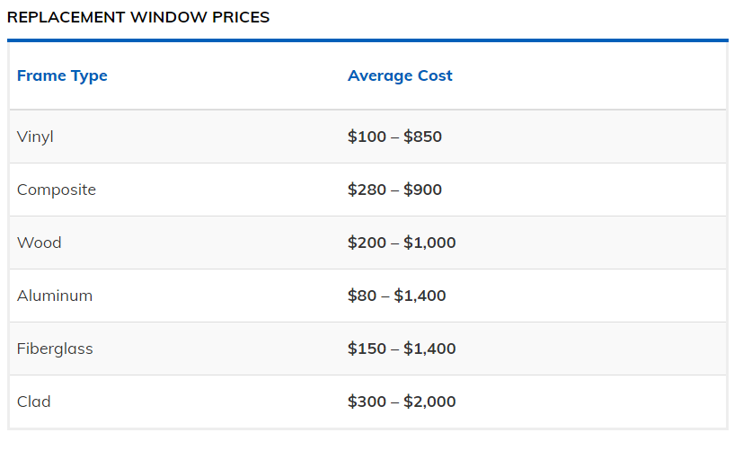

- Lumber Cost Variability Illustrates the Minor Cost of Bird-safe Residential Glass. Builders may object to the uncertainty in price for bird-safe glass. The builder regularly budgets for lumber cost variability. The lumber cost of a typical home is about $10,000 for a 2,500 sq. ft. home (NAHB) The average monthly variation in lumber costs is $247 (2000-2010 Fed Reserve, not the current unusual market). The variability in lumber cost month to month is 5 times more than a hypothetical increased cost of 25% for bird-safe glass.

- Conservative Assumptions

This analysis is based on conservative assumptions.

The cost of windows in new homes and glass purchased by a manufacturer may be much less than the retail price on which these estimates are based. Therefore the 10%. 25% and 50% premiums for bird-safe glass would be proportionally lower.

The analysis used the NAHB estimate of 2.4% for the cost of the windows in a new home. In fact, that 2.4% also includes doors, including the garage door. Thus, the price of the windows may be much less than 1%. See page 9.

Political Feasibility of Bird-safe Residential Codes

The low cost of bird-safe glass makes a safe bird glass code requirement politically viable. No buyer will notice $3 more in his or her monthly mortgage. As noted above, the developer plans for far greater variability in lumber prices than the bird-safe glass premium. A cost difference of less than 2% for bird-safe glass will be hardly noticeable to the builder or developer.

Polling to Assess the Market Potential of Bird-safe Replacement Windows

With regard to replacement windows, with this sensitivity analysis we know the questions that need to be asked in a poll to assess consumer acceptance of bird-safe replacement window. The polls could ask, “If you buy 20 replacement windows at a cost of about $12,000 would you be willing to pay $9, $23, $48 more per month for bird-safe glass.” With this information we can determine at what price the additional cost of bird-safe glass is acceptable

- The National Association of Home Builders Estimates of Window Share of Construction Costs

The NAHB annually provides a breakdown of the costs of a new home. Note below in line 1B that the construction cost is about 60% of the home’s cost. Thus the 4% is 2.4% in the cost of the windows. Under Section II, Construction Costs, line IV. O, note that 4% cost includes both windows and doors, including the garage doors. In this analysis. The care about 85% of the window-door package.

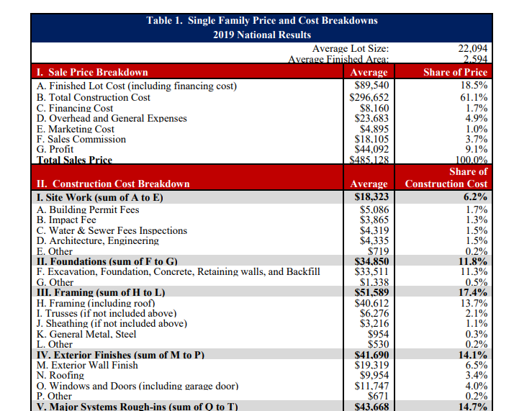

. Here it is explained in a table.

4.00% | Windows and doors are 4% of the cost of a new home
2.40% | Materials are 60% of home cost- NAHB - so windows cost 2.4%
2.04% | less garage door 85%
0.67% | glass 33% of cost of window DOE data
0.84% | only the glass is more expensive, not the whole window - add 25% for bird-safe glass extra cost

- Glass Cost Estimate

The invoice for the glass pane used in this analysis follows. Note that this is a consumer sale and the wholesale price may be much lower.

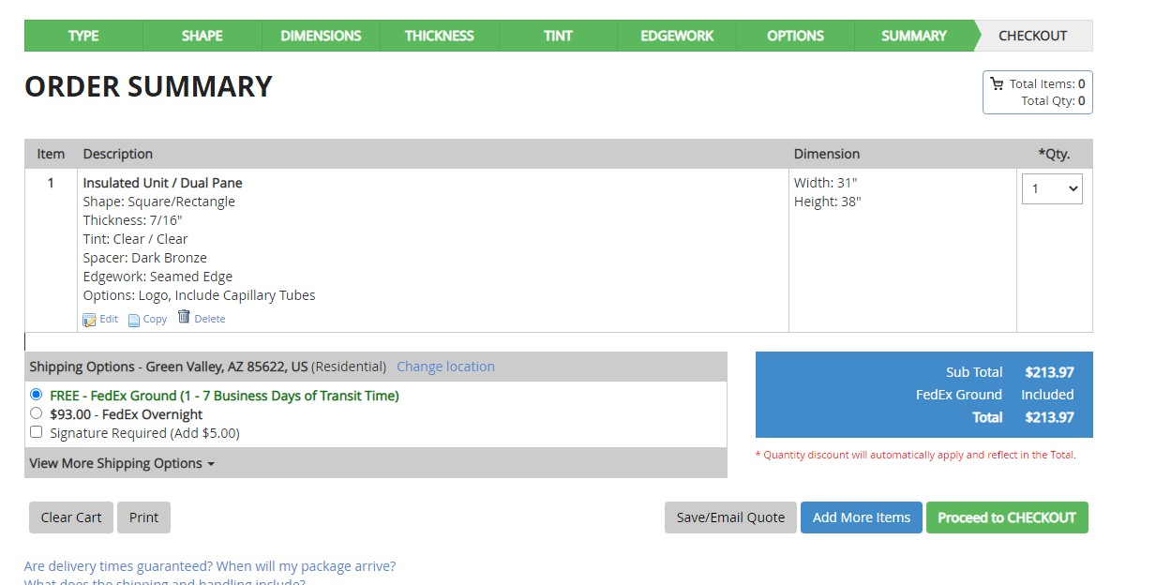

- Vinyl Vs. Wood Comparison

The added cost for a wood frame window, compared to a vinyl, is $143. This is seven (7) times the 10% premium for bird-safe glass, three times the 25%, and about the same 50% premium.

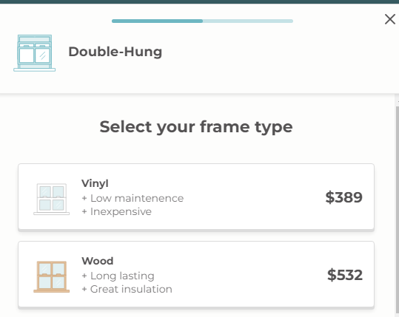

- Article appearing in Warbler Magazine 2018 July Warbler, p.2. Another concern was making Marmot safe for birds. Research tells us that up to 1 billion birds are killed by window strikes each year in the United States alone, making it one of the leading conservation issues for bird populations. Portland Audubon’s bird-safe program, led by Mary Coolidge, works with architects and developers to synergize the energy, performance, and design objectives with bird-safe measures. Bird-safe glass is becoming increasingly common in commercial construction, but is not as readily available for smaller buildings. At Marmot Cabin, our Operations Director, Xander Patterson, paired commercial bird-safe glass with residential window frames. Easier said than done: only one major manufacturer, Jeld-Wen, was willing to provide empty window frames for the project. State-of-the art bird-safe glass—with ultraviolet stripes most birds can see but humans cannot—was provided by GlasPro. A local window supplier, Irvington Building Supplies, agreed to assemble them. It wasn’t easy, but the beautiful results will save birds, serve as an education tool to teach kids and adults about bird-safe solutions, and hopefully help blaze the trail for future bird-safe residences and smaller buildings. Mary Coolidge of Portland Audubon added: “They ended up being no more expensive than the Marvin windows that had originally been specified for the project.” Posted on the Collisions Listserv.

- The computations on which the data in the executive summary are based are presented in the spreadsheet that follows or which can be downloaded at https://ornithologycenter.com/birdsafeaffordable/.

This section explains the spreadsheet that follows. It has two parts. The first explains how the estimates of the cost of a bird-safe window were developed. The second explains how the estimates of the effect of the price of bird-safe glass on the consumer’s monthly debt service payment, were developed.

The spreadsheet is the source of the cost estimates in the summary.
.
Section1. Computing the Cost of Bird-safe Glass

Separate Glass Cost from Window Cost

To determine the cost impact of bird-safe glass, the cost of the glass needs to be separated from the cost of the window. The installed window cost also includes the frame, delivery, and all the other costs associated with installation.
Cost of A Pane of Glass. A supplier, One Day Glass will deliver a pane of double paned window glass 31” by 38” for the price indicated at F5 (Pink) This separates the cost of the glass from the price of the window. The cost of glass is only about 30% of the installed window cost. It does not change as the window is manufactured, delivered, and installed.

Added Cost of Bird-safe Glass. The added cost of bird-safe glass was determined by multiplying the cost of the pane of glass by 10% 25% and 50%. As an example, if the glass costs $100, the added cost is +$10, +$25, +$50 respectively. In this case the added cost ranges from $21-$107. G7-G9 Dark yellow (The 3 Scenarios 10%, 25% and 50% were recommended by an industry expert.)

Glass Costs Are Constant The costs related to glass do not change thereafter.
The Manufactured Cost of a Window. The Home Depot cost for the same sized window as the pane of glass was used to approximate the cost of a manufactured window (Wholesale prices are not available.) It does not include installation, but does include some amount for shipping and retail markup. D12 Light Blue $330.

Cost of Bird-safe Installed Window. The cost of the installed window is about twice the cost of the manufactured window (D19) Red (DOE estimate) The added costs of bird-safe glass, from G7-G9 are added to the base installed cost resulting in an installed price for bird-safe windows shown in D20-D22 Bright green. Note that only the glass cost increases, not the cost of the other elements of the installed window.
Glass Share of Window Cost. The percentage of the cost of the installed window which is glass is computed is shown at E24. The added cost of the bird-safe windows as a per cent of the base installed cost are at E25-E27 Blue. If the manufactured cost is less, the percentage of added cost of bird-safe glass will go up. For every $100, it will increase by 1%, 2% and 5%.

Using actual costs, this results in a window costing between $700 and $800. The average cost of an installed replacement window is $600. Window prices vary by $600 depending on the type and quality of the frame, the type of glass and other factors.

Section 2. Effect on Final Consumer Monthly Debt Service Payments

The cost the consumer sees is not the cost of the bird-safe glass, it is the amount he or she pays for the installed window. Thus, the next step is to estimate the effect on the consumer price of adding bird-safe windows. Since homes and most large purchases are financed, the change in the monthly payment is estimated.

Replacement windows and windows in new construction are the two largest markets for residential glass.

Replacement Windows Cost of Bird-safe Glass

The base installed cost is at E32 (from D19) The cost of an installed bird-safe window is the installed base cost (D32) plus the added costs of the bird-safe glass from G7-G9. The cost of the installed bird-safe windows is shown at E33-E35. If the buyer orders 10 windows, the costs are shown of the 10 windows is shown at D40-D42. It is assumed that the buyer finances with a home improvement loan. An online calculator for home improvement loans (8% -10years) was used to determine the effect on monthly payment of 10 bird-safe windows vs. ordinary glass windows. The monthly payment for each scenario is at E39-E42. The extra cost per month is shown at F40-F42. Yellow

Section 2. New Home Cost of Bird-safe Glass.

The new home bird-safe window costs are computed differently. The NAHB estimates that the windows are 2.4% of the finished cost of a home. (See Background NAHB section.) Using a $300,000 home as base case, the cost of all the home’s windows is $7,200. E4 Light Green

As this table indicates the added cost will be less than 2.4% - which is used as a conservative assumption.

4.00% | Windows and doors are 4% of the cost of a new home
2.40% | Materials are 60% of home cost- NAHB - so cost 2.4%
2.04% | less garage door 85%
0.67% | glass 33% of cost of window DOE data
0.84% | only the glass is more expensive, not the whole window - add 25%

The cost of the bird-safe glass windows is the cost of the windows plus the added cost of bird-safe glass. To determine the cost of the bird-safe windows, the installed cost ($7,200) is multiplied by the percentages in E25-E27. Blue. These are the percentages that the added cost of safe glass is of the cost of standard glass installed window. The added cost to a home for each scenario is at E51-E53. Light pink G51-G53 shows the added cost of safe windows as percentage of the purchase price

These additional costs for bird-safe glass are added to the $300,000 cost of the home to determine the cost of the home with bird-safe glass. F56-F58. Dark Blue

An online mortgage calculator was used to estimate the added cost of safe glass for the whole home compared to monthly payment for ordinary glass. (used 5.78% for 30 years.) The increase in the monthly payment for using bird-safe windows is at G63-G65.(purple)

Copy of Spreadsheet Follows

