The Positive Outlook for Residential Bird Safe Windows

A Report of the Ornithology Center at Muhlenberg College

Dr. Daniel Klem
Director

Jim Cubie, Author
Consultant to the Ornithology Center at Muhlenberg College
September 2022

Contact
Jimcubie1gmail.com
843-991-1059

Related Documents at ______

Is The Cost Of Bird Safe Glass A Barrier To Its Use In New Residential Construction Or Replacement Windows?
Jim Cubie
Ornithology Center at Muhlenberg College
Jimcubie1@gmail.com 843-991-1059

Executive Summary

Residential windows kill several hundred birds annually. Thus is essential that bird safe glass be used wherever possible. Progress in this effort has been stymied by the assumption that bird safe glass is too expensive. This analysis shows that is not the case.

The cost of bird safe glass will not be a significant barrier to its use in the two largest residential glass markets – new homes and replacement windows. This is the case because -

- In new homes the cost of the windows is less than 3% of the total cost of the home. (Source: National Association of Home Builders.) Therefore, even if bird safe glass is significantly more expensive, it will increase the monthly payment by only $2-$6 for a $300,000 home.
- In replacement windows, the glass itself is about 30% of the cost of the installed window. If bird safe glass costs 25% more than ordinary glass, it only adds 7.5% to the cost of the replacement window – or $30 to the cost of a $400 replacement window. It will increase the monthly payment for 10 windows by between $2 and $10. A single window unit, without bird safe glass, can cost between $300 and $1,200 for standard sizes – a price range so broad it can accommodate the cost of bird safe glass.

Purpose: This memorandum evaluates the effect on consumer acceptance of the possible increased cost of bird safe glass in residences. It includes both replacement windows and new construction. It does not address the availability of bird safe glass windows. This analysis does not apply to commercial buildings. The conclusions in this summary are the result of an in-depth analysis which are shown in the spreadsheet in the Background document. Other important information is there also.

Why Use Scenarios. Since we do not know what the cost difference of bird safe glass is or will be, the best approach is to use several scenarios. The 3 scenarios assume that bird safe glass is 10%, 25% and 50% more expensive. This range was confirmed by an industry expert. The costs from the three scenarios provide the information needed to assess the future cost implications of bird safe glass.

Three Key Concepts

- Twenty-five Per Cent More is Not 25% More The idea that bird safe glass costs may cost 25% or 50% more than standard glass does not mean that a window with safe glass is 25% more costly. The glass itself is only about 30% of the cost of the window installed. So if bird safe glass cost 20% more it is only 7.5% more costly.
- The Customer Does Not Buy Bird Glass The customer buys an installed window – not the glass. The purchase of a new home or set of replacement windows is usually financed. Thus the question, from a consumer point of view, is “how much does the increased cost of the bird safe glass add to the monthly payment.” The installation of bird safe glass would raise the monthly payment for a new home $300,000 by $2-$6 and the cost of ten (10) replacement windows by between $2-$10 per month.

- Cost Goes Down as Demand Increases

The price of another glass product, solar panels, illustrates how the price of bird safe glass can fall rapidly as demand increases. Under Swanson’s Law, the price drops by 20% for every doubling of shipped product. The cost of solar panels has generally been following Swanson’s Law. Home solar installation costs have fallen from $57,000 to $24,000 in 10 years – about in half. The price of solar equipment has dropped by 89% since 2010.

Competitive market

Prices come down in competitive markets. There are over 20 manufacturers of bird safe glass at the American Bird Conservancy site.

Costs of Bird Safe Glass In Perspective

  - The variation in the prices for standard windows are between $300 and $1,200. This difference is far more than the highest cost scenario..
  - Consumers will pay more for better windows. The cost difference between a vinyl and a wood clad window at retail is about $143. That is seven times the 10% premium for bird safe glass, three times the 25% premium, and about the same 50% premium.
  - The variability in lumber costs which builders expect is five times the premium for bird safe glass in the 25% scenario.

The computations on which these conclusions are based are in a spreadsheet at the end of this document or can be downloaded at https://ornithologycenter.com/birdsafeaffordable/

Background Material

- Bird Safe Glass
- Costs in Perspective
  - Wide variation in window prices
  - The difference in wood clad window over vinyl is far greater than the cost of bird safe glass in two scenarios
  - The variability in lumber costs is far greater than the premium for bird safe glass
- Conservative assumptions
- Political feasibility of bird safe residential building codes
- Implications for commercial bird safe glass affordability
- Polling to assess the market potential of bird safe replacement costs
- NAHB estimates for window share of construction costs.
- Glass cost estimate
- Vinyl vs. wood comparison
- Explanation of spreadsheet and spreadsheet

What is Bird Safe Glass

Birds hit glass for two main reasons; they either think it is a clear space that they can fly through or see the reflection of habitat that they want to fly to. Glass can be only be considered Bird-Safe if birds recognize it as a barrier. The reflective and or see-through quality must be eliminated by covering the surface with a film, coating, or visual pattern alerting the birds to its presence. For reflective placements, this must be on the outside surface (surface #1) and at a minimum, follow the 2” x 4” rule. For glass in a see-through setting, the visual pattern can be on any surface, as long as there is always equal light on both sides of the glass, allowing an internal pattern to be clearly seen at all times.

Added Cost Of Bird Safe Glass Costs In Perspective

- According to Home Adviser, window installation costs on average $5,860, or between $2,950 and $9,051. Labor typically costs $150 to $800 per window, or about $40 an hour per person. A single window unit can run between $300 and $1,200 for standard sizes, far more than even a 50% premium for bird safe glass ($107).

- Vinyl vs. Wood Cost Difference Exceeds Bird Safe Premium The cost difference between a vinyl and a wood clad window at retail is about $143. That is seven times the 10% premium for bird safe glass, three times the 25%, and about the same as the 50% premium.

- Lumber Cost Variability Illustrates the Minor Cost of Bird Safe Residential Glass Builders may object to the uncertainty in price for bird safe glass. The builder regularly budgets for lumber cost variability . The lumber cost of a typical home is about $10,000 for a 2,000 sq. ft. home (NAHB) The average monthly variation in lumber costs is $247 (2000-2010 Fed Reserve, not the current unusual market) The variability in lumber cost month to month is 5 times more than a hypothetical increased cost of 25% for bird safe glass

- Conservative Assumptions

This analysis is based on conservative assumptions.

The cost of windows in new homes and glass purchased by a manufacturer may be much less than the retail price assumed in this analysis. Therefore the 10%. 25% and 50% premiums for bird safe glass would be proportionally lower.

The analysis used the NAHB estimate of 2.4% for the cost of the windows in a new home. In fact, that 2.4% also includes doors, including the garage door. Thus the price of the windows may be much less than 2.4%

Political Feasibility of Bird Safe Residential Codes

The low cost of bird safe glass makes a safe bird glass code requirement politically viable.. No buyer will notice a difference in his monthly mortgage loan of $3. As noted above, the developer plans for far greater variability in lumber prices than the bird safe glass premium. A cost difference of less than 2.4% for bird safe glass will be hardly noticeable to the builder or developer.

Implications for Commercial Bird Safe Glass

The effect on the final cost of the proposed building, if it is all clad with glass, will probably be more than the effect on residential construction. However, other costs may be present in urban buildings (foundations, moving utilities, planning and permitting) that are not present in new homes. In a tract home development the “soft costs” can be amortized over 100-1,000 homes. In an urban building all such costs are part of the cost of a single building. Installation costs may be much higher in urban buildings. Likewise many urban buildings are not glass clad, so that the added cost of bird safe glass will not be significant in the monthly payments which service the loan or bond. Also, some private urban buildings and municipal buildings, are financed with bonds which have very long amortization periods and very low costs. In each case the added cost of the glass should be compared to the loan amortization level to see if the difference is significant.

Polling To Assess the Market Potential of Bird Safe replacement Windows

With regard to replacement windows, with this sensitivity analysis we know the questions that need to be asked in a poll to assess consumer acceptance of bird safe replacement window. The polls could ask, “If you buy 20 replacement windows at a cost of about $12,000 would you be willing to pay $9, $23, $48 more per month for bird safe glass.” With this information we can determine at what price the additional cost of bird safe glass is acceptable

- The National Association of Home Builders Estimates of Window Share of Construction Costs

The NAHB annually provides a breakdown of the costs of a new home. Note below in line 1B that the construction cost is about 60% of the home’s cost. Under Section II, Construction Costs, line IV. O, note that 4% cost includes both windows and doors, including the garage doors. In this analysis, I have not subtracted the cost of the garage door and other doors. This may lower the 4% substantially.

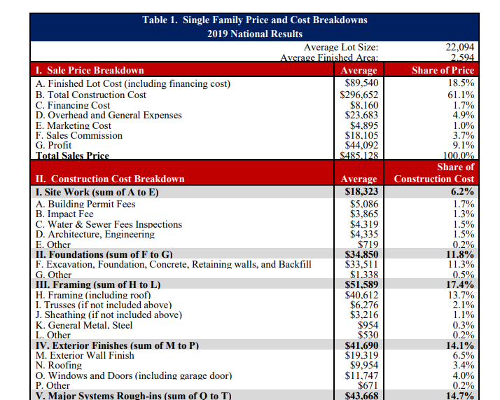
.

- Glass Cost Estimate

The invoice for the glass pane used in this analysis follows. Note that this is a consumer sale and the wholesale price may be much lower.

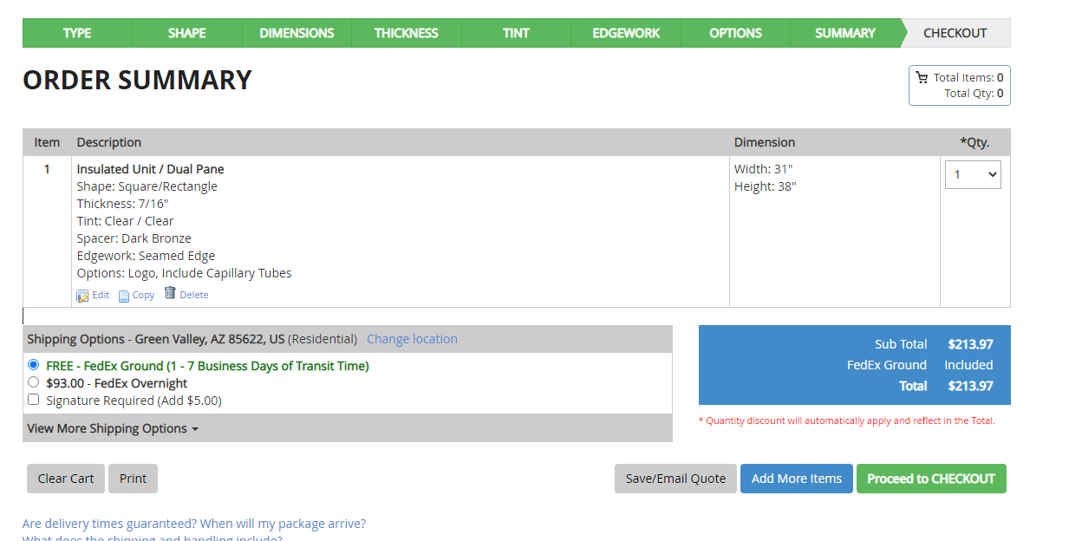

- Vinyl Vs. Wood Comparison

The added cost for a wood frame window, compared to a vinyl, is $143. This is seven (7) times the 10% premium for bird safe glass, three times the 25%, and about the same 50% premium.

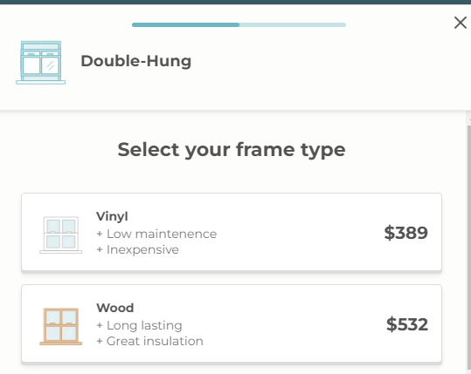

- The computations on which the data in the executive summary are based are presented in the spreadsheet that follows or which can be downloaded at https://ornithologycenter.com/birdsafeaffordable/

This section explains the spreadsheet that follows. It has two parts. The first explains how the estimates of the cost of a bird safe window were developed. The second explains how the estimates of the effect of the price of bird safe glass on the consumer’s monthly debt service payment, were developed.

The spreadsheet is the source of the cost estimates in the summary.
.
Section1. Computing the Cost of Bird Safe Glass

Separate Glass Cost from Window Cost

To determine the cost impact of bird safe glass, the cost of the glass needs to be separated from the cost of the window. The installed window cost also includes the frame, delivery, and all the other costs associated with installation.
Cost of A Pane of Glass A supplier, One Day Glass will deliver a pane of double paned window glass 31” by 38” for the price indicated at F5 (Pink) This separates the cost of the glass from the price of the window as a whole. The cost of glass is only about 30% of the installed window cost. It does not change as the window is manufactured, delivered and installed.

Added Cost of Bird Safe Glass The added cost of bird safe glass was determined by multiplying the cost of the pane of glass by 10% 25% and 50%. As an example, if the glass costs $100, the added cost is +$10, +$25, +$50 respectively. In this case the added cost ranges from $21-$107. G7-G9 Dark yellow (The 3 Scenarios 10% 25% and 50% were recommended by industry expert.)

Glass Costs Are Constant The costs related to glass do not change hereafter.
The Manufactured Cost of a Window The Home Depot cost for the same sized window as the pane of glass was used to approximate the cost of a manufactured window (Wholesale prices are not available.) It does not include installation, but does include some amount for shipping and retail markup. D12 Light Blue $330.

Cost of Bird Safe Installed Window The cost of the installed window is about twice the cost of the manufactured window (D19)Red (DOE estimate) The added costs of bird safe glass, from G7-G9 are added to the base installed cost resulting in an installed price for bird safe windows shown in D20-D22 Bright green. Note that only the glass cost increases, not the cost of the other elements of the installed window.
Glass Share of Window Cost. The percentage of the cost of the installed window which is glass is computed is shown at E24. The added cost of the bird safe windows as a per cent of the base installed cost are at E25-E27. Blue If the manufactured cost is less, the percentage of added cost of bird safe glass will go up. For every $100, it will increase by 1%, 2% and 5%.

Using actual costs, this results in a window costing between $700 and $800. The average cost of an installed replacement window is $600. Window prices vary by $600 depending on the type and quality of the frame, the type of glass and other factors.

Section 2. Effect on Final Consumer Monthly Debt Service Payments

The cost the consumer sees is not the cost of the bird safe glass, it is the amount he pays for the installed window. Thus, the next step is to estimate the effect on the consumer price of adding bird safe windows. Since homes and most large purchases are financed, the change in the monthly payment is estimated.

Replacement windows and windows in new construction are the two largest markets for residential glass.

Replacement Windows Cost of Bird Safe Glass

The base installed cost is at E32 (from D19) The cost of an installed bird safe window is the installed base cost (D32) plus the added costs of the bird safe glass from G7-G9. The cost of the installed bird safe windows are shown at E33-E35. If the buyer orders 10 windows, the costs are shown of the 10 windows is shown at D40-D42. It is assumed that the buyer finances with a home improvement loan. An online calculator for home improvement loans (8% -10years) was used to determine the effect on monthly payment of 10 bird safe windows vs. ordinary glass windows. The monthly payment for each scenario is at E39-E42. The extra cost per month is shown at F40-F42. Yellow

Section 2. New Home Cost of Bird Safe Glass.

The new home bird safe window costs are computed differently. The NAHB estimates that the windows are 2.4% of the finished cost of a home. (See Background NAHB section.) Since this amount also includes the doors, including the garage door, the percentage may be significantly lower. Using a $300,000 home as base case, the cost of all the home’s windows is $7,200. E4 Light Green

The cost of the bird safe glass windows is the cost of the windows plus the added cost of bird safe glass. To determine the cost of the bird safe windows, the installed cost ($7,200) is multiplied by the percentages in E25-E27. Blue. These are the percentages that the added cost of safe glass is of the cost of standard glass installed window. The added cost to a home for each scenario is at E51-E53. Light pink G51-G53 shows the added cost of safe windows as percentage of the purchase price

These additional costs for bird safe glass are added to the $300,000 cost of the home to determine the cost of the home with bird safe glass. F56-F58. Dark Blue

An online mortgage calculator was used to estimate the added cost of safe glass for the whole home compared to monthly payment for ordinary glass. (used 5.78% for 30 years.) The increase in the monthly payment for using bird safe windows are at G63-G65.(purple)

Cost Per Bird Saved

As avian conservationist, we should be asking, “What is the least costly option to save a bird.” If we do not know this how can we target our efforts? The costs per birds saved as a result of the added cost of safe glass is shown at E75-E81. Dark green.

